1. What is polynomial regression?

It’s used when data points are arranged in a non-linear fashion.

It’s also called polynomial linear regression. It doesn’t depend on variables, instead, it depends on the coefficients, which are arranged in a linear fashion.

It’s not the same as multiple linear regression: it has only one independent variable. This means that the dependent variable is modeled as a linear function of the independent variable. Multiple linear regression has multiple independent variables.

Here’s some examples:

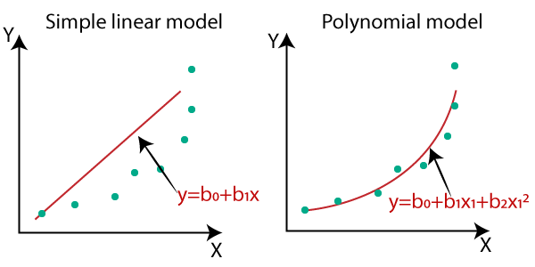

1. What is R squared for linear regression?

It’s a statistical measure in a regression model that determines the proportion of variance in the dependent variable that can be explained by the independent variable.

In other words, r-squared shows how well the data fit the regression mode.

R-squared can be measured with the equation: $R^{2}=\frac{Var\left(mean\right)-Var(line)}{Var(mean)}$

It’s way better than R as it’s easier to interpret and the difference between two correlations is more obvious.

1. Compare between cost function and loss function.

|  |  |  |
| --- | --- | --- |
|  | Cost function | Loss function |
| Usage | When calculating loss we consider only a single data point | when calculating the sum of error for multiple data |
| capture the difference between the actual and predicted values for a single record | aggregate the difference for the entire training dataset. |
| The Most commonly used loss functions are: Mean-squared error and Hinge loss. |  |

1. List other cost functions for linear regression

Huber Loss: is a combination of MSE and MAE

Quantile Loss: is useful when you want to predict a specific quantile of the target variable rather than minimizing the mean error.

1. Work on tvmarketing.csv dataset and create notebook like you saw